A Rare Opportunity to purchase an attractive parcel of land conveniently situated close to Colyton, Devon.
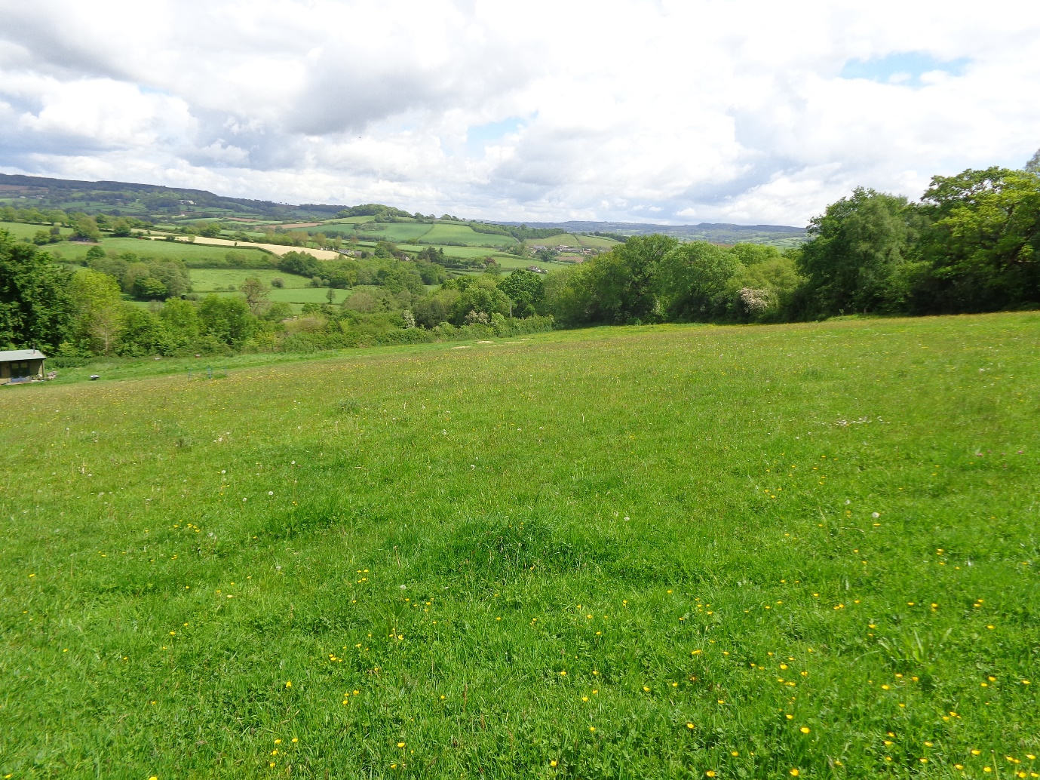
Land at Heathhayne Cross
Colyton
Devon,
EX24 6RS

For Sale by Private Treaty.

Offers in the region of £85,000 for the whole.
Available in smaller lots if required but not at a pro rata price

Description
A readily accessible, gently sloping parcel of land extending to 8.36 acres (3.38ha) with permission to site a shepherds hut and two storage arcs.
This useful parcel of land is situated approximately one mile from the much sought after town of Colyton, and boasts two access points, one straight from Southleigh Road and the other via a Right of Way (marked on the attached plan).
Enclosed by hedgerow boundaries, with a stunning vista, in a sheltered location and being land of good quality, the land lends itself to use for equestrian purposes as well as agricultural or even amenity use (subject to the relevant planning requirements).
For sale as a whole with offers invited in the region of £85,000, or in various lots which are open to discussion.

Situation
Conveniently located in the delightful Coly Valley, the land enjoys stunning rural views out over the surrounding countryside which mostly consists of pasture land and woodland.
The nearby town of Colyton offers a broad spectrum of local services including shops, post office, parish church, restaurants, public houses, primary school and the much acclaimed Colyton grammar School is located close by at Colyford. Neighbouring towns include Seaton (3 miles), Axminster (6 miles) and Honiton (10 miles). Train stations at both Axminster and Honiton and the A30 at Honiton allow ease of access to the main routes to London and Exeter.

Tenure
The land is of Freehold tenure. Vacant possession upon completion.

Services
Natural water serves the land. There are no mains services.

Rights of Way, Easements & Wayleaves.
A Right of Way marked on the attached plan offers one of the points of access for this parcel of land.
The land is sold subject to all rights of way, easements, and wayleaves of telephone and telegraph poles, stays, wires, electric pylons, poles and cables, water and gas pipes that are presently erected on and passing over or under the land, and subject to the agreements affecting the same should there be any.

Designations
The land is situated in an Area of Outstandiing Natural Beauty within East Devon.
The land is not entered into any agricultural or environmental management schemes.

Basic Payment Scheme
The land is being sold without the benefit of any entitlements to Basic Farm Payment.

Method of Sale
The land is for sale by Private Treaty

Viewing
Viewing is strictly by arrangement with the Sole Agents Glaspers
Coombe View Farm, Branscombe, Seaton, Devon, EX12 3BT
Tel: 01297 680218 Email: glaspers@btconnect.com Website: www.glaspers.co.uk

Directions
Travelling East on the A35 from Honiton, turn right at Taunton Cross signposted for Shute and Colyton. Continue along this road until you come to a T-junction, whereupon turn right to enter Colyton. Continue into Colyton on Dolphin Street until you reach the Square, where you turn sharp right onto Queen Street signposted for Sidmouth and Exeter. Take the first left hand turn onto Sidmouth Road and continue up the hill. Take the next right hand turn AFTER the cemetery, signposted Southleigh. Continue for approximately ¼ of a mile until you come to Hethhayne Cross. The land is situated a short distance after Heathhayne Cross on the left hand side.
Please see location plan attached.

Local Authorities

East Devon District Council
The Knowle, Sidmouth, Devon, EX10 8HL

Devon County Council
County Hall, Topsham Road, Exeter, Devon, EX2 4QD

Fencing Covenant
Should the land be sold as separate lots, the dividing fencing costs will have to be discussed further and will depend on how many lots the land is eventually sold in.

Development Covenant
The land is sold subject to a covenant preventing any future development, with the exception of stables and field shelters for private use. This includes the land being used for camping or for the siting of caravans, motorhomes or boats.

Property Misdescriptions Act 1991
We hope you will find our sale particulars useful and reliable however if you have a particular point of interest, please don’t hesitate to contact our office to seek further clarification.

Please note!
All measurements are approximate. These sale particulars are intended as a general guide and Glaspers have not carried out any surveys or tests on water etc.

